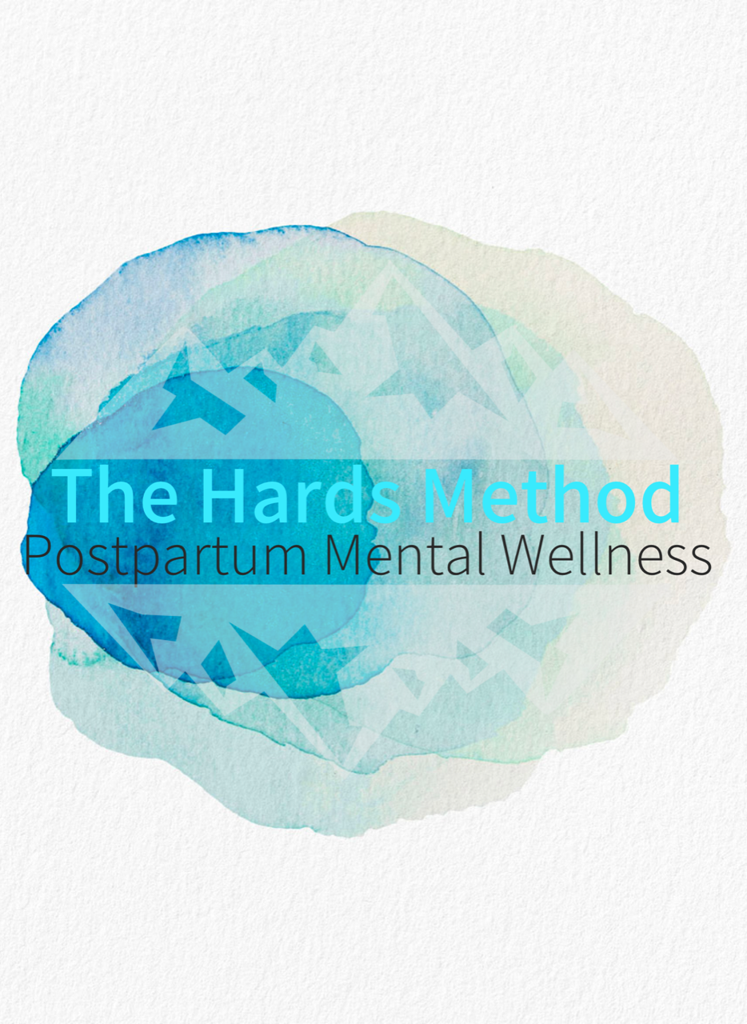

Name: (include your contact info)

Partner (if applicable): (name and contact info)

Due Date:

Welcome to The Hards Method and congratulations on your pregnancy! You are so wise to plan for your mental well-being postpartum. Many people experience mental illness and Postpartum Depressions (PPD) to varying degrees. Screening processes for PPD are part of the regular postpartum check-ups; however, even with screening, some people can fall through the crack and be left feeling under-supported. That is NOT OK.

The Hards Method is a mental wellness planning tool that aims to help you identify how you would like to be supported when baby arrives. It identifies your supports, your ideas, your plans, who you are, what you need, and how you would like to be treated. This will become a vital tool in aiding you and your support people through that first year and beyond. The Hards Method will raise awareness in yourself so that if PPD should happen to take hold, you are able to recognize the situation and take action. The questions asked in the Hards Method will provide information to give you and your care provider(s) a clear understanding of what you are like when you are well. By understanding what you are like when you are well, it will be easier to spot signs of when you are unwell.

There are three sections to the Hards Method:
- Getting to Know Yourself when you are Expecting
- Your Supports; and
- When the Wheels are Falling Off

Getting to Know Yourself When you are Expecting-

Vision:
What do you envision Parenthood to be like? What to hope it looks like? How do you think you will feel if this idea you have created does not come to fruit?
__________________________________________________________________________________________________________________________________________________________________________________________________________________________________________________________________________________________________________________________________________________________________________________________________________________________________________________________________________________________________________________
__________________________________________________________________________________________________________________________________________________________________________________________________________________________________________________________________________________________________________________________________________________________________________________________________________________________________________________________________________________________________________________

It is normal for you to not have that immediate-rose colored glasses-awe and wonder-fantasized moment when you first meet baby after delivery. On a scale of 1-10 1 being not at all and 10 being extremely, how devastated do you think you would be if you do not have an immediate connection to baby?
1 2 3 4 5 6 7 8 9 10

Your thoughts and needs on feeding your child:
When considering your feeding plans, whether it is breast-feeding, formula or both, on a scale of 1-10, 1 being not at all 10 being extremely, how attached are you to your plan.
1 2 3 4 5 6 7 8 9 10

Family History: Have you or anyone in your immediate family previously experienced postpartum depression?
If yes, list them and try to describe the severity of their PPD. If applicable, describe the severity, length, and onset of your own previous experience.
__________________________________________________________________________________________________________________________________________________________________________________________________________________________________________________________________________________________________________________________________________________________________________________________________________________________________________________________________________________________________________________
__________________________________________________________________________________________________________________________________________________________________________________________________________________________________________________________________________________________________________________________________________________________________________________________________________________________________________________________________________________________________________________

Prenatal Baseline:
To better appreciate your mental health in the postpartum period – after baby arrives – it is useful to get to know yourself before the baby arrives. Take a moment to describe yourself. Are you generally bubbly, quiet, sensitive or quick-witted? Pragmatic, chaotic, serious? Do you laugh easily? Do you cry easily?
___________________________________________________________________________________________________________________________________________________________________________________________________________________________________________________________________________________________________________________________________________________________________________________________________________________________________________________________________________________________________________________________________________________________________________________________________________________________________________________________________________________________________________________________________________________________________________
Describe what it typically looks like when you are coping with challenging events or stress; how long is normal for you to be mad, upset, hurt, disappointed etc.? Describe normal strategies and coping skills you use in difficult times. An example might be deep breathing or exercise.
__________________________________________________________________________________________________________________________________________________________________________________________________________________________________________________________________________________________________________________________________________________________________________________________________________________________________________________________________________________________________________________
________________________________________________________________________________________________________________________________________________________________________________________________________________________________________________________________________________________________________________________________________________________________________________________________________________________________________________________________________________________________________________________________________________________________________________________________________________________________________________________________________________________________________________________________________________________________________________________________________________

Coping Skills: ________________________________________________________________________________________________________________________________________________________________________________________________________________________________________________________________________________________________________________________________________________
__________________________________________________________________________________________________________________________________________________________________________________________________________________________________________________________________________________________________________________________________________________________________________________________________________________________________________________________________________________________________________________

Routines:
Undoubtedly your routine will change with the needs and rhythm of your child. However, your habits, routines and needs are aspects of your mental health. List the basics of your current weekly routine. Ensure that you recognize those activities/items that need to remain in place for you even after your baby arrives. For example, attending church service on Sunday, meditating Tues and Thurs, eating pizza Friday nights. _______________________________________________________________________________________________________________________________________________________________________________________________________________________________________________________________________________________________________________________________________________________________________________________________________________________________________________________________________________________________________________________________________________________________________________________________________________________________________________________________________________________________________________________________________________________________________________________________________________________________________________________________________________________________________________________________________________________________________________________________________________________________________________________________________________________________________________________________________________________________________________________________________________________________________________________________________________________________________________________________________________________________________________________________________________________________________________________________________________________________________
__________________________________________________________________________________________________________________________________________________________________________________________________________________________________________________________________________________________________________________________________________________________________________________________________________________________________________________________________________________________________________________
Daily Routine:
A daily routine, much like a weekly routine, can promote a person’s sense of feeling in control and balanced. List activities you do on a daily basis that support your prenatal baseline and keep you feeling in control and balanced. This could include your daily hygiene routine, or perhaps you enjoy reading a book every evening, etc.
____________________________________________________________________________________________________________________________________________________________________________________________________________________________________________________________________________________________________________________________________________________________________________________________________________________________________________________________________________________________________________
__________________________________________________________________________________________________________________________________________________________________________________________________________________________________________________________________________________________________________________________________________________________________________________________________________________________________________________________________________________________________________________

Upkeep Items:
These are different from your daily routine or weekly routine. You do not need to do these activities on a scheduled or regular basis. They are activities you seek to further support your baseline or to boost your mood, and improve your feeling of control and balance. For example, cleaning your home, getting a massage, cooking a nice meal, taking a long hot bath, gardening, meeting with friends and so on.
___________________________________________________________________________________________________________________________________________________________________________________________________________________________________________________________________________________________________________________________________________________________________________________________________________________________________________________________________________________________________________________________________________________________________________________________________________________________________________________________________________________________________________________________________________________________________________

Engaging activities:
List activities that sound fun to you. These activities can later be used for ideas when your supports want to reach out to you and get you engaging in life outside of baby and possible postpartum depression. List as many ideas as you like, for example, pottery, walking, singing, badminton, etc.
_____________________________________________________________________________________________________________________________________________________________________________________________________________________________________________________________________________________________________________________________________________________________________________________________________________________________________________________________________________________________________________________________________________________________________________________________________________________________________________________________________________________________________________________________________________________________________________________________________________________________________________________________________________________________________________________________________________________________________________________________________________________________________________________________________________________________________________________________________________________________________________________________________________________________________________________________________________________________

Managing Expectations:
Recognize that we all carry expectations into parenthood, whether they are about feeding, sleeping, daily routines, relationships or emotions. List those areas for which you think you might have big expectations and how you might manage disappointment. Be honest.
_____________________________________________________________________________________________________________________________________________________________________________________________________________________________________________________________________________________________________________________________________________________________________________________________________________________________________________________________________________________________________________________________________________________________________________________________________

Your Supports

Support Friends:
This list should include friends and family members that you whole-heartedly trust to be honest with you. That you can trust with your personal stories. People who have your best interest at heart and will respect you fiercely. Provide names, contact info and their relation to you. List them in order of importance.
1. (Name - contact info - relation)
2. (Name - contact info - relation)
3. (Name - contact info - relation)
4. (Name - contact info - relation)
5. (Name - contact info - relation)

Hired and Professional Supports:
For example: Doula, midwifes, therapists, Doctors and so on. Provide names, contact info and their relation to you. List them in order of importance.
1. (Name - contact info - relation)
2. (Name - contact info - relation)
3. (Name - contact info - relation)
4. (Name - contact info - relation)
5. (Name - contact info - relation)

In your corner:
This section is for who will be your advocate(s) should you no longer be able to advocate for yourself. Include name, contact info and relation)
(Name - contact info - relation)
(Name - contact info - relation)

When the Wheels are Falling Off

The wheels are falling off:
Taking into account the prenatal baseline you described, and reflecting on the past, can you describe what it might look like in times when you feel out of control, unbalanced and off your baseline? These queues or red flags are identifiers for your personal and professional support people can look out for and pay attention to. These are signs you might be struggling:
____________________________________________________________________________________________________________________________________________________________________________________________________________________________________________________________________________________________________________________________________________________________________________________________________________________________________________________________________________________________________________
__________________________________________________________________________________________________________________________________________________________________________________________________________________________________________________________________________________________________________________________________________________________________________________________________________________________________________________________________________________________________________________

What to do:
If your support people identify some concerns, what would you like to see happen? Describe how you would like to be cared for in the event that you do get postpartum depression. Try and answer the following questions - What makes you feel supported? How do you like to be communicated with? How can people approach you in ways that feel non-confrontational? Are your supports allowed to plan interventions if you are in deep denial about PPD? Should they schedule more follow frequent follow-ups, in home, via phone and/or email? Dig deep for this one.
____________________________________________________________________________________________________________________________________________________________________________________________________________________________________________________________________________________________________________________________________________________________________________________________________________________________________________________________________________________________________________
__________________________________________________________________________________________________________________________________________________________________________________________________________________________________________________________________________________________________________________________________________________________________________________________________________________________________________________________________________________________________________________ ____________________________________________________________________________________________________________________________________________________________________________________________________________________________________________________________________________________________________________________________________________________________________________________________________________________________________________________________________________________________________________
__________________________________________________________________________________________________________________________________________________________________________________________________________________________________________________________________________________________________________________________________________________________________________________________________________________________________________________________________________________________________________________

Relationships:
Can you think of triggers to avoid in your current relationship? In contrast, can you also think of activities or conversations that you would find helpful/supportive from your relationship either with your current partner, family or friend? Be as specific as you can.
_________________________________________________________________________________________________________________________________________________________________________________________________________________________________________________________________________________________________________________________________________________________________________________________________________________________________________________________________________________________________________________________________________________________________________________________________________________________________________________________________________________________________________________________________________________________________________________________________________________________________________________________________________________________________________________________________________________

How can I support my wellness postpartum?
What are small things you can do to support your wellness once baby arrives? It can be as simple as splashing cold water on your face and taking time to breath consciously. Scheduled baths where you can rely on a support to give you an hour of alone time.
____________________________________________________________________________________________________________________________________________________________________________________________________________________________________________________________________________________________________________________________________________________________________________________________________________________________________________________________________________________________________________
__________________________________________________________________________________________________________________________________________________________________________________________________________________________________________________________________________________________________________________________________________________________________________________________________________________________________________________________________________________________________________________

What can others do to help?
Through foresight, what task can you picture being a challenge. In example getting groceries, doing the dishes, housework. Would having someone do these things be helpful?
____________________________________________________________________________________________________________________________________________________________________________________________________________________________________________________________________________________________________________________________________________________________________________________________________________________________________________________________________________________________________________
__________________________________________________________________________________________________________________________________________________________________________________________________________________________________________________________________________________________________________________________________________________________________________________________________________________________________________________________________________________________________________________

What will cause damage?
Think of things, actions, or words that will be the opposite of beneficial?
____________________________________________________________________________________________________________________________________________________________________________________________________________________________________________________________________________________________________________________________________________________________________________________________________________________________________________________________________________________________________________
__________________________________________________________________________________________________________________________________________________________________________________________________________________________________________________________________________________________________________________________________________________________________________________________________________________________________________________________________________________________________________________

Reminders:
It is very easy to feel overwhelmed and steamrolled by the amount of unsolicited advice/opinions people are going to undoubtedly share with you. Know your boundaries and limitations – express them and stand by them. Focus on baby and baby's well-being and the examples you want to show baby. Take a moment to remind yourself what values are important to you. Describe your limits or boundaries.
____________________________________________________________________________________________________________________________________________________________________________________________________________________________________________________________________________________________________________________________________________________________________________________________________________________________________________________________________________________________________________
__________________________________________________________________________________________________________________________________________________________________________________________________________________________________________________________________________________________________________________________________________________________________________________________________________________________________________________________________________________________________________________

Remember your Coping Skills:
Earlier you were asked to describe your coping skills. These are the skills and strategies you might need to use if it feels like the wheels are falling off. Take a moment without looking back and list them again. Now, reflect - Do you feel like you have enough coping skills? Are there others you would like to learn? For example, visualization or breathing exercises used in Cognitive Behaviour Therapy? If you recognize that you feel underprepared, discuss this with your doctor or a mental health provider. They can help you acquire more skills. And once you have more, list them here.
_________________________________________________________________________________________________________________________________________________________________________________________________________________________________________________________________________________________________________________________________________________________________________________________________________________________________________________________________________________________________________________________________________________________________________________________________________________________________________________________________________________________________________________________________________________________________________________________________________________________________________________________________________________________________________________________________________________

Off the Rails - No grey areas:
Describe a detailed and clear plan identifying your wishes should you experience postpartum depression so bad that you are unable to advocate for yourself.
____________________________________________________________________________________________________________________________________________________________________________________________________________________________________________________________________________________________________________________________________________________________________________________________________________________________________________________________________________________________________________
__________________________________________________________________________________________________________________________________________________________________________________________________________________________________________________________________________________________________________________________________________________________________________________________________________________________________________________________________________________________________________________

Decision Making:
The following Professionals are NOT to be involved in anyway making decisions for my mental health care or treatment.
- [insert name]
- [insert name]
- [insert name]

If there is a dispute between my personal support people, [insert name] will have final say and I nominate this individual to advocate on my behalf, in consultation with medical professionals.

Complete the following section if you have a history of mental illness.

Anxiety, Dissociation, Fight or Flight-

What do your anxiety attacks look and feel like:
List all the signs and symptoms you can think of. Name the ones that you feel on the inside and ones that will be visible/noticeable to your supports.
____________________________________________________________________________________________________________________________________________________________________________________________________________________________________________________________________________________________________________________________________________________________________________________________________________________________________________________________________________________________________________
__________________________________________________________________________________________________________________________________________________________________________________________________________________________________________________________________________________________________________________________________________________________________________________________________________________________________________________________________________________________________________________

Dissociation signs:
If applicable ask someone who has witnessed you dissociate if they noticed things that you did prior to. Pay attention to what queues your body is giving you prior to. Perhaps there are some nervous ticks you have.
____________________________________________________________________________________________________________________________________________________________________________________________________________________________________________________________________________________________________________________________________________________________________________________________________________________________________________________________________________________________________________
__________________________________________________________________________________________________________________________________________________________________________________________________________________________________________________________________________________________________________________________________________________________________________________________________________________________________________________________________________________________________________________

What triggers your fight or flight response?
What types of things generally trigger your anxiety and, if applicable, dissociation?
____________________________________________________________________________________________________________________________________________________________________________________________________________________________________________________________________________________________________________________________________________________________________________________________________________________________________________________________________________________________________________
__________________________________________________________________________________________________________________________________________________________________________________________________________________________________________________________________________________________________________________________________________________________________________________________________________________________________________________________________________________________________________________

Prescribed Medication: OPTIONAL
If you wish to have your support people know what medications you are on, please list them below. As well, include allergies and/or adverse reactions to prescriptions that you may have.
____________________________________________________________________________________________________________________________________________________________________________________________________________________________________________________________________________________________________________________________________________________________________________________________________________________________________________________________________________________________________________
__________________________________________________________________________________________________________________________________________________________________________________________________________________________________________________________________________________________________________________________________________________________________________________________________________________________________________________________________________________________________________________
Additional Notes:
____________________________________________________________________________________________________________________________________________________________________________________________________________________________________________________________________________________________________________________________________________________________________________________________________________________________________________________________________________________________________________
____________________________________________________________________________________________________________________________________________________________________________________________________________________________________________________________________________________________________________________________________________

Release of Information:

DATE:

I, , hereby give my permission for all the above-mentioned members of my support team to exchange information pertaining to my mental wellness postpartum. I give permission for them to freely discuss any of the above-mentioned topics.

This permissions voids information pertaining to:
____________________________________________________________________________________________________________________________________________________________________________________________________________________________________________________________________________________________________________________________________________________________________________________________________________________________________________________________________________________________________________
___________________________________________________________________________________
I understand that I have the right to withdraw my consent at any time with any or all of the above listed service providers.

Signed: (expectant parent)
Signed: (witness)

